

STRATEGIC PLAN AND COLLECTIVE VISION

2025-2027

Version 2.0 – Updated June 1, 2026
New Mexico Public School Facilities Authority

https://nmpsfa.org/  (505) 843-6272 | 1312 Basehart SE, Suite 200  Albuquerque, NM 87106-4365 | 
TABLE OF CONTENTS
PSFA OVERVIEW 3
MESSAGE FROM THE EXECUTIVE DIRECTOR 4
STRATEGIC PLAN EXECUTIVE SUMMARY 5
Our Mission – What we strive to accomplish for our Stakeholder 5
Our Vision – What we aspire to become as the future unfolds 5
Our Core Values – What we are committed to as we serve New Mexico 6
Transparency 6
Teamwork 6
Integrity 6
Growth 6
Accountability 6
Responsiveness 6
STRATEGIC OBJECTIVE 1: ENHANCING ORGANIZATIONAL STRENGTHS 7
Why this is important 7
Goals to address this strategic objective: 7
STRATEGIC OBJECTIVE 2: BUILDING SUSTAINABLE FACILITIES 8
Why this is important 8
Goals to address this strategic objective 8
STRATEGIC OBJECTIVE 3: STRENGTHENING COMMUNITY ENGAGEMENT 9
Why is this important 9
Goals to address this strategic objective 9

PSFA OVERVIEW
The New Mexico Public-School Facilities Authority (PSFA) was established by the Legislature in 2002 as a result of the Zuni Lawsuit, in which three NM school districts challenged the equity of State Capital Outlay distribution and won their case. Pursuant to 22-24-9 NMSA 1978, PSFA reports to, and operates as staff to the Public-School Capital Outlay Council (PSCOC), manages a funding model that distributes state capital outlay to schools according to greatest needs first (determined by modern, standardized, best practice and industry standards), and assists school districts with facilities, energy development and management thereafter.

The Public-School Capital Outlay Council (PSCOC), pursuant to 22-24-6 NMSA 1978, manages the allocation of state funding to public school facilities in New Mexico’s 89 school districts, state-chartered schools and 2 constitutional schools. The PSCOC consists of nine council members from the Governor’s Office, the Department of Finance & Administration (DFA), the Public Education Commission (PEC), the Legislative Education Study Committee (LESC), the Public Education Department (PED), the New Mexico School Boards Association (NMSBA), the Construction Industries Division (CID), the Legislative Finance Committee (LFC), and the Legislative Council Service (LCS). The PSCOC reports to the Public-School Capital Outlay Oversight Task Force (PSCOOTF) which is made up of legislators, senior leaders from school districts and charters, and members of the public.
The PSFA has been in existence now for 23 years supporting New Mexico Public Schools with improving facility conditions through Capital Outlay funding streams. The New Mexico Public School Capital Outlay process provides adequate and sustainable school facilities as a result of legislation in response to the Zuni Lawsuit.

- Capital outlay funding has had a valuable impact to the 60 million+ sq. ft. of public-school floor space, spanning public, charter schools and 2 constitutional schools, exceeding $3 Billion in investments to the building and systems infrastructure, modernizing facility conditions supporting positive student outcomes.

- New Mexico’s public-school facilities repair needs are prioritized objectively and all school districts are eligible for Capital Outlay funding equally.

School District FAD assessments are used to rate this funding process as fair and equitable and maintenance assessments aid in determining how well a district is maintaining the public-school building assets over time through formal, measurable and repeatable performance metrics.

- Maximizing tax-payer dollars, the Public-School Capital Outlay Council (PSCOC) awards funding from the legislature to the greatest needs first on the final ranked condition of schools.
State funds serve as an incentive for local communities to provide matching funds.

MESSAGE FROM THE EXECUTIVE DIRECTOR


Marcos B. Trujillo
Executive Director
I am humbled and privileged to be chosen as the next Executive Director of the Public School Facilities Authority (PSFA). I want to express my gratitude for the opportunity to lead such an important organization. Through the dedication of the PSFA staff, "Our vision is to position the organization as a recognized leader by fostering a culture of innovation, operational excellence, and providing sustainable growth”.

Over the next 1-3 years, we will pursue a strategic path built on three core priorities: delivering exceptional value to our NM school districts through high-quality products and services, empowering staff by investing in growth opportunities, professional development, and cross-functional collaboration to provide transparent and equitable practices that create measurable positive impacts to our public school communities.

We will achieve these priorities by leveraging data-driven decision-making, embracing emerging technologies in all facets of the agency’s infrastructure, maintaining the ability to adapt and evolving as market conditions change, evolving code requirements to construction and maintenance for a total cost of ownership experience. Our leadership team will ensure that every initiative aligns with our mission, supports our long-term vision, and strengthens our agency’s foundation. By cultivating strong stakeholder partnerships, fostering transparency, and holding ourselves accountable to measurable outcomes, we will navigate change with confidence and resilience.

This strategic plan is not just a roadmap—it is a commitment to our New Mexico stakeholders that we will act with integrity, accountability and equity with purpose, and deliver sustainable results that endure well into the future.
Partnering with New Mexico Communities
to provide quality, sustainable school facilities
for our students and educators.

STRATEGIC PLAN EXECUTIVE SUMMARY

PSFA devoted five months of iteration to refreshing its strategic plan. Through surveys, focus groups and internal conversations, the PSFA Executive Team invited all staff and Public-School Capital Outlay Council members to provide input that will guide the future of the organization. Our teamwork resulted in the co-designed vision, mission, values, objectives, and goals below. In addition to this strategic plan, PSFA developed an organizational work plan that outlines how internal departments will accomplish goals during the next three years. Annual reports will highlight the progress toward goals measured through key performance indicators. As the PSFA continues to proactively partner with districts and stakeholders, our inherent goals of improving process efficiency, reducing and streamlining project costs, and encouraging effective building system lifecycles through better maintenance continues to be at the forefront of our initiatives.
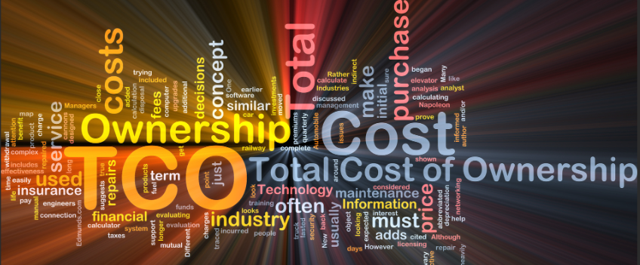

Our Mission – What we strive to accomplish for our Stakeholders
To steward resources in support of high-quality school facilities that bolster student outcomes.

Our Vision – What we aspire to become as the future unfolds
Partner with New Mexico’s public schools to create excellent educational facilities.

Our Core Values – What we are committed to as we serve New Mexico

Transparency
Being open and forthcoming about the organization’s operations matters to stakeholders. Providing information about finances, budgets, projects, and policy making are important factors that drive change, build trust and enhance accountability.

Teamwork
Collaborating with teams of subject matter experts and district co-owners drives common goals efficiently and effectively working towards common goals and positive outcomes.

Integrity
We are committed to a firm adherence to moral values and commitment to quality at all levels maximizing taxpayer dollars and contributions.

Growth
Supporting the continuous process of efforts for professional improvement and development among members of our agency supporting continued training, professional development thereby enhancing the strength of our agency.

Accountability
We strive to build public trust in State government, building repeatable data driven processes, demonstrating best practices, improved communications and proven outcomes.

Responsiveness
We strive to be responsive, attentive, and fair in our communication with our stakeholders, delivering data driven results in an organized manner.

STRATEGIC OBJECTIVE 1: ENHANCING ORGANIZATIONAL STRENGTHS

Why this is important
Investing in our people, processes and systems through the strategic pillars of sustaining continuous improvement, encouraging cross-department collaboration, enhancing transparency, empowering expertise, unifying our narrative and fostering forward thinking.

Goals to address this strategic objective:
- Offer professional development and technical resources aligned with career pathing goals to each department.
- Build process driven policy and procedure manuals for all departments supported by cross-teaming.
- Implement a robust performance evaluation process cultivating a proactive employee-engaged work culture.
- Continue to integrate industry standards and best practices into our systems.
- Review software to enhance improved financial and operational alignment and tracking of deliverables.

STRATEGIC OBJECTIVE 2: BUILDING SUSTAINABLE FACILITIES

Why this is important
Co-creating welcoming spaces where children can flourish for many years to come.

Goals to address this strategic objective
- Analyze data to drive best practices in design, construction and maintenance.
- Ensure data integrity across all platforms.
- Develop robust performance dashboards for stakeholders.
- Improve efficiency in design, construction and streamlining costs.

STRATEGIC OBJECTIVE 3: STRENGTHENING COMMUNITY ENGAGEMENT

Why is this important
Learning with and from our partners to build sustainable facilities.

Goals to address this strategic objective
- Continue engaging community groups and garnering input from stakeholders on how to be more responsive.
- Increase outreach, training, and marketing emphasizing impact.
- Enhance the agency website to streamline internal and external customer tools and resources.
- Assess district leaders’ needs through routine surveys driving customer-centric practices.

